Setup Instructions for
Fibonacci Retracements & Projections

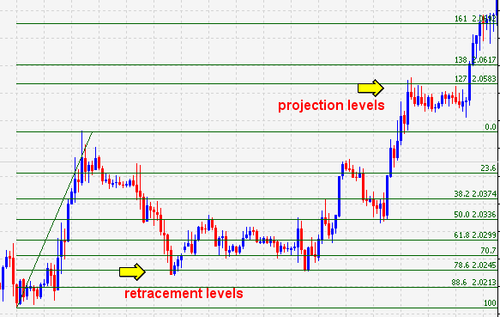

Using the Fibonacci drawing tool on Metatrader 4, we can set the parameters to provide retracement and projection levels at the same time, with just one line.
This can be done manually by typing in the new numbers (Example 1), or you can copy and paste fib levels into the Programs / Metatrader 4 / Config / Terminal files (Example 2).
EXAMPLE 1
On your toolbar, click Insert, Fibonacci, and select Retracement. Or click the Fib tool icon
Draw a Fibo line anywhere on your chart and double left click on the line to make the Grab Points appear. Right click on the line then click Properties.

- Click the Fibo Levels tab

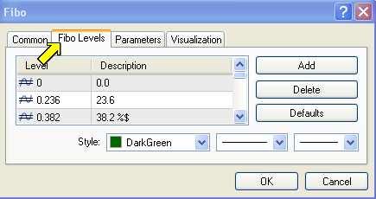
- Enter the additional Values highlighted in yellow from the table below.
(%$ adds the price of the line to your chart)

- To make changes to existing levels and descriptions double click the number.

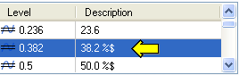
- To add new levels click the Add button.
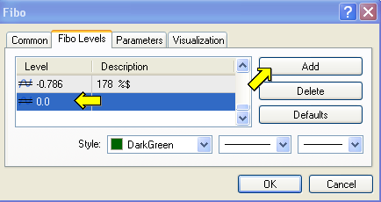
MT4 comes with some existing Fibonacci levels (not highlighted), just add the %$ to these where suggested.

Level Description
0 0
.236 23.6
.382 38.2 %$
.5 50.0 %$
.618 61.8 %$
.702 70.7
.786 78.6 %$
.886 88.6 %$
1.00 100
1.27 127 %$
1.382 138 %$
1.618 161 %$
1.786 178 %$
2.00 200 %$
2.618 261 %$
-.275 127 %$
-.382 138 %$
-.618 161 %$
-.786 178 %$
-1.00 200 %$
-1.618 261 %$
4.236 423.6 delete this number by highlighting and clicking the delete button

EXAMPLE 2:

You can set up your Fibo parameters an easier, faster way, by copying and pasting the following numbers into the appropriate MT4 folder.

- Copy the following data to your clipboard. (Highlight, right click, select copy)

[Objects]
Fibo_color=25600
Fibo_style=0
Fibo_weight=1
Fibo_background=0
Fibo_color2=25600
Fibo_style2=0
Fibo_weight2=1
Fibo_levels=21
Fibo_level0=0
Fibo_description0=0.0
Fibo_level1=0.236
Fibo_description1=23.6
Fibo_level2=0.382
Fibo_description2=38.2 %$
Fibo_level3=0.5
Fibo_description3=50.0 %$
Fibo_level4=0.618
Fibo_description4=61.8 %$
Fibo_level5=0.707
Fibo_description5=70.7
Fibo_level6=0.786
Fibo_description6=78.6 %$
Fibo_level7=0.886
Fibo_description7=88.6 %$
Fibo_level8=1
Fibo_description8=100
Fibo_level9=1.275
Fibo_description9=127 %$
Fibo_level10=1.382
Fibo_description10=138 %$
Fibo_level11=1.618
Fibo_description11=161 %$
Fibo_level12=2
Fibo_description12=200 %$
Fibo_level13=2.618
Fibo_description13=261 %$
Fibo_level14=-0.275
Fibo_description14=127 %$
Fibo_level15=-0.382
Fibo_description15=138 %$
Fibo_level16=-0.618
Fibo_description16=161 %$
Fibo_level17=-1
Fibo_description17=200 %$
Fibo_level18=-1.618
Fibo_description18=261 %$
Fibo_level19=1.786
Fibo_description19=178 %$
Fibo_level20=-0.786
Fibo_description20=178 %$
Fibo_level21=-4.618
Fibo_description21=561 %$
Fibo_level22=1.786
Fibo_description22=178 %$
Fibo_level23=-0.786
Fibo_description23=178 %$
Fibo_level24=1.786
Fibo_description24=178 %$
Fibo_level25=-0.786
Fibo_description25=178 %$
Fibo_level26=-5.618
Fibo_description26=661 %$
Fibo_ray=0
Fibo_level27=1.786
Fibo_description27=178 %$
Fibo_level28=-0.786
Fibo_description28=178 %$
- Open your FXDD Metatrader 4/ Config / terminal file. (double click terminal to open)

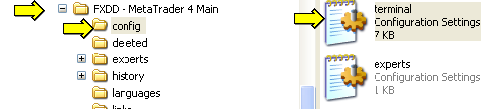

- Scroll down until you find the line containing “[Objects]”.

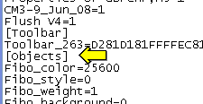

- Highlight and Delete the data from that line to the end of the Fibo data.

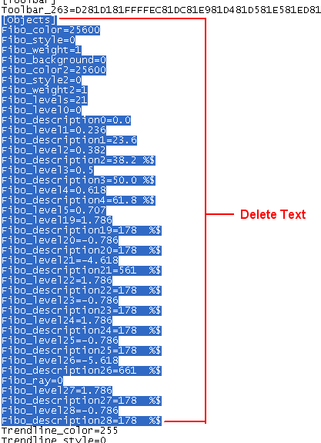

- Paste the data you just copied from the clipboard into that same spot to replace the old fib parameters.
- Click File, Save to save the file.
- You’re done, close the windows.

Now when you draw a Fibonacci line you will have retracement and projection lines on the same tool.

